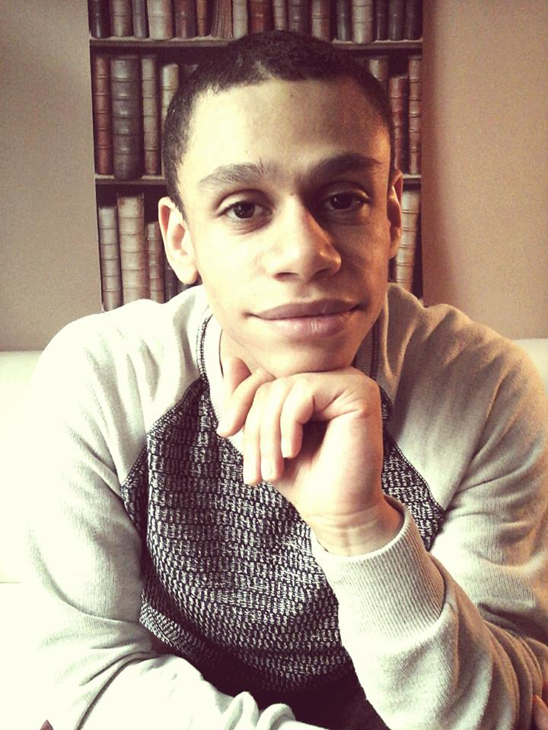
Curriculum Vitae

PERSONAL INFO
Name: Elias Schroons
Address: Vlaamsesteenweg 135, 1000 Brussels
Mobile: +32(0)471/02.19.14
Email: elias@eliasschroons.com
Nationality: Belgian
Birthplace: Borgerhout
Date of Birth: 23/10/1992
Marital Status: Married
Employment Status: Freelancer/Self-Employed

EDUCATION
- 2007 - 2010 3de KSO Diction
4de KSO Diction
5de KSO Diction
6de KSO Diction
Kunsthumaniora Brussel
Chrysantenlaan 26
1020 Laken, Brussels
Belgium

- 2015 - 2016 Full Stack Web Development
Free Code Camp (Computer Software Engineer)

EXPERIENCE
- Customer Support – USG Professionals (08/2012 – 02/2014)
Alfons Gossetlaan 54
Near Brussels
Belgium

Being part of the Customer Support team, I mostly received inbound calls from customers who were dissatisfied and about to cancel their services with the company. It was my job to remind them why they chose us in the first place and work through any difficulties the client was currently facing with our company. Individually assessing the situation, I took charge of the conversation and made the caller feel like a valued customer.

- Community Manager & Copywriter – MyMicroinvest (03/2015 – 07/2015)
Sinter-Goedeleplein 5
1000 Brussels
Belgium

SKILLS
- Social
- Objective
- Entrepreneurial Spirit
- Online Marketing
- (Copy)Writing
- Pragmatic
- Ambitious
- Front-End Web Development (HTML, CSS, JavaScript)
- WordPress
- Version Control (Git)

LANGUAGES
Dutch : Native
French: Good
English: Native

